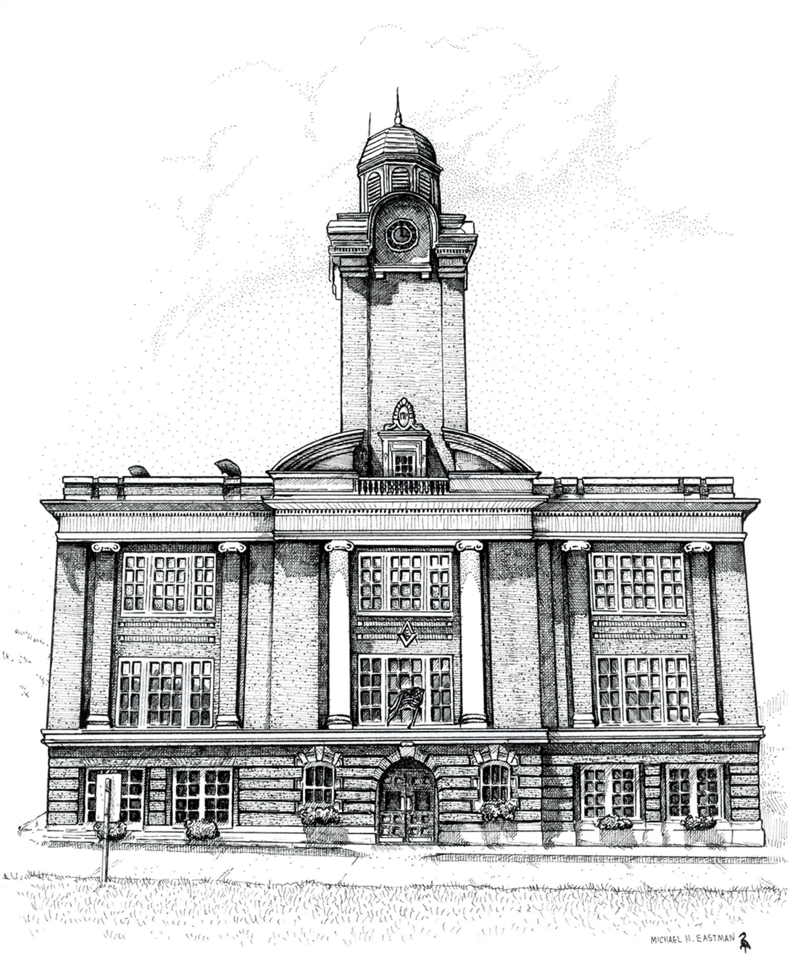 | Gorham Town Hall  20 Park Street  Gorham, NH 03581  Phone: 603-466-3322  Fax: 603-466-3100
Press Release
Contact: Denise Vallee  Phone: (603) 466-3322 | FOR IMMEDIATE RELEASE  3 P.M., January 14,2012

the medallion Opera House
Gorham, nh: The Gorham Board of Selectmen approved a new name for the auditorium, The Medallion Opera House, located in the renovated Town Hall.
Work first began on the Opera House in April of 1915. In June of that same year the first motion pictures were shown – James O’Neil in The Count of Monte Cristo and Mary Pickford in The Eagles Mate – the charge was ten cents for children and fifteen cents for adults! With such a great history, The Gorham Auditorium Committee suggested a name that recognized the historical aspects along with the 8-foot ceiling medallion, an architectural feature that captures your eye as soon as you enter the theater.
The Medallion Opera House is now booking many exciting events for the 2012 season, including a benefit concert featuring Red Gallagher for the White Mountain Rotary Club’s Local Scholarship Funds on Saturday, February 11th; hosting two St. Kieran Community Center for the Arts events: Grand Derangement Band on Sunday, February 12th at 2 pm and Cabin Fever Follies, an annual community talent show, on Sunday, February 26th at 2 pm; Imperial Russian Faberge Eggs: from Fine Art to Fine Craft, sponsored by the NH Humanities Council on Friday, March 23rd at 7 pm and Saturday, March 24th at 10 am; The Gorham Players production of The Princess and the Pea, on Thursday, Friday and Saturday, March 29,30 and 31st at 7 pm; an original production, Ethnic Origins and Immigration, sponsored by the NH Humanities Council on Thursday, April 19th at 6:30 pm, Theatre North’s production of Walden-A Ballad of Thoreau, on Friday and Saturday, April 20th-21st at 7 pm and on Sunday, April 22nd at 2 pm. For more information, and if you would like to receive notices of upcoming events, you may subscribe to receive e-mail alerts on the Town’s new website, at www.gorhamnh.org.
-End-

